|  |
| --- |
| **Submitted to : Sir M Ali Hassan**  **Name: Namatullah**  **Reg no : fa19-bcs-403**  **Assignment N0 : 01 and no 02**  **Web technology** |

Assignment 1

GITHUB LINK <https://github.com/sayedNamat-Mosavi/web-assignmentProfolio.git>

Live at https://sayednamat-mosavi.github.io/web-assignmentProfolio/

Assignment 2

GITHUB LINK <https://github.com/sayedNamat-Mosavi/WebsiteAssignment2.git>

live at https://sayednamat-mosavi.github.io/WebsiteAssignment2/

**Screen shots**

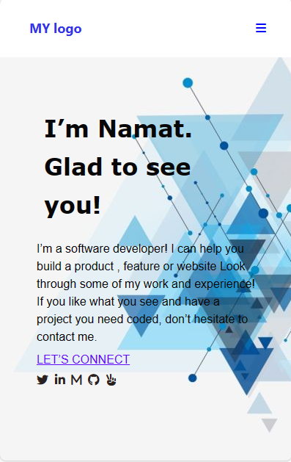

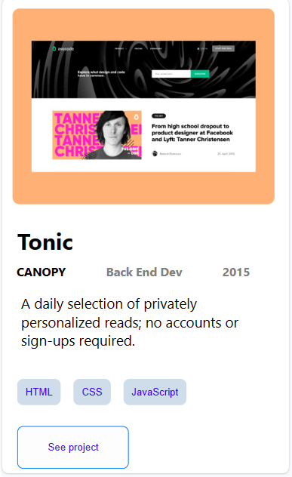

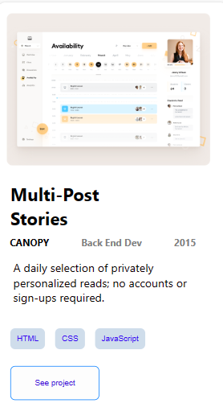

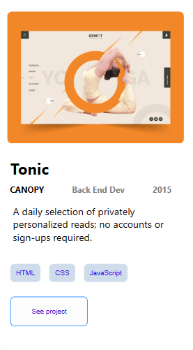

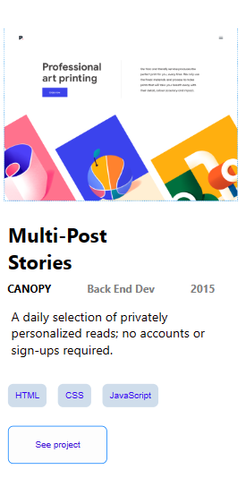

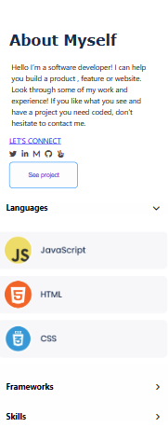

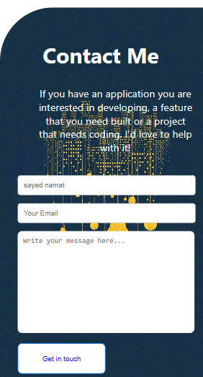

**Web mobile**

